SERVICES WE OFFER

**Logistics Capabilities** – When it comes to choosing a logistics solution, industry-specific knowledge, technology, scale and scope of services are all important considerations. At Ingenious we provide you with nonpareil solutions to expand your reach to every corner you desire. We combine our deep understanding of the customer’s internal & external requirement with our strategic approach, providing a one-stop solution to get your brand on the go and Ingenious has specialists who has decades of experience in providing solutioning for safe, efficient contract logistics for B2B and B2C goods: apparel, cosmetics, consumer electronics, food and beverages, appliances, consumer packaged goods, furniture, aerospace parts, chemicals, medical equipment and more.

We can also provide kitting, packaging and other high-value-add services, including end-to-end reverse logistics management of merchandise returns. . Our approach focuses on how we deliver operational excellence to provide viable, cost-effective technology-enabled solutions to the most challenging logistics & supply chain management questions. We reciprocate through our work entirely with a progressive mindset.

Below is the glimpse of ingenious capabilities to take the Logistics to the next level.

**What Ingenious can do…..**

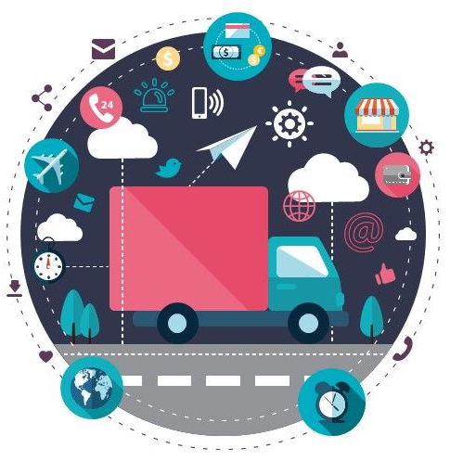

**B2B** (also known as business-to-business)

**B2C** (also known as business-to-consumer)

**Geographical Possibilities** (Domestic /Export)

**E-Commerce** (First Mile, Last Mile, Returns)

**LTL / PTL / FTL** with Track and Trace

**How Ingenious can do…..**

**Study Solution Deployment**

* Packaging solution tailored for maximum logistics capacity utilization and strengthening value on investment.
* Offer FTL or LTL/Part Load logistics services based on business regional requirements – Domestics & Export.
* Introduce best suit logistics service providers with optimized solution.
* Address the field / regional concerns via logistics solution designing for end customer / dealer satisfaction.
* Solutions on E-Commerce based on business requirements.

**Mode of Logistics Ingenious offers…..**

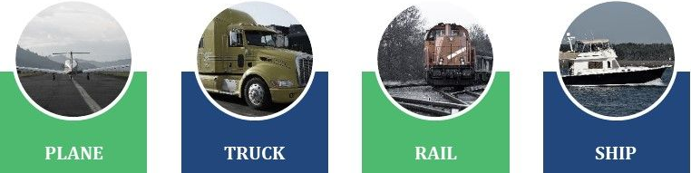

**Type of Distribution Ingenious offers….**

